Monthly mileage reports are to be submitted using the Shelby County Schools Employee Portal. Attached is a copy of the Mileage Reimbursement Schedule and instructions for entering mileage using the Employee Portal. Approved local travel mileage will be reimbursed at the current IRS allowable rate. The mileage reimbursement rate will be 62.5 cents per mile.

Do not accumulate and submit mileage for several months at a time. Only mileage incurred during the month’s reporting period will be reimbursed. Please remember mileage reimbursement does not include driving from your residence to your normal work location, as well as the distance from your work location back to your residence.
If you have any questions, please contact Kimberly Engram in Finance, (901) 416-5597. Thank you for your cooperation in this matter.

- Access Shelby County Schools Website: www.scsk12.org

- Click Employee:
Go to Employee
Portal.
- Log In: User ID and PIN  **User ID and PIN is your active directory log in** | 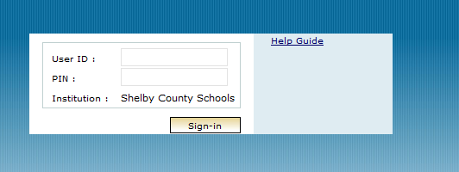
- Click Reimbursements | 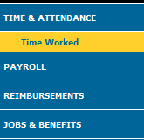
- Click Mileage | 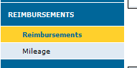
- Click “Enter New Claim” | 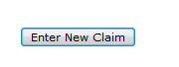
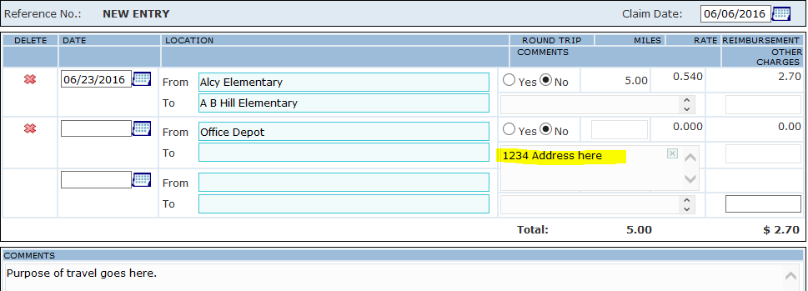

- Complete Date Field

- Select From and To Locations, a drop down of locations will occur as you type. If no drop down box, add the address for the location. See highlighted area.

- Select Round Trip (Yes or No)

- Miles will populate and total miles times mileage reimbursement rate will calculate. If miles do not populate automatically, please add the appropriate mileage.

- Add additional From and To Locations if required

12. Use the comment box to put the Purpose of Travel.

PLEASE SUBMIT ONE REQUEST FOR MILEAGE PER MONTH, ADD ADDITIONAL TO AND FROM LOCATIONS AS NEEDED ON THE SAME REQUEST. DO NOT SUBMIT MULTIPLE FORMS IN THE SAME MONTH

13. If you are not finished and would like to come back later click

14. If you have finished your entries FOR THE MONTH click

APPROVAL PROCESS

When approving mileage, you have seven different options, but not all will be used:
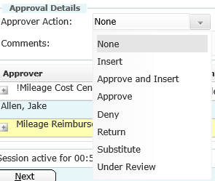
Insert: This option is to insert an approver who needs to approve the mileage entry before you do.
Approve and Insert: This option is to approve the mileage entry and insert an approver who is supposed to approve after you, but before the final approval
Approve: This option is to approve the mileage entry and send it to the final approver.
Deny: This option is to deny the mileage entry *NOTE: Once this option is selected, it completely voids the entire entry. DO NOT use this option if the entry has a mistake or if you are uncertain about the entry*
Return: This option is to return the mileage entry back to the employee to correct any errors made on the entry.
Substitute: This option is to substitute your approval to the proper approver. *NOTE: Use this option when you know you are not the correct approver for the mileage entry*

PLEASE read and understand each approval task. If you have any questions about any task, please feel free to reach out to Kimberly Engram at (901)416-5597 BEFORE selecting a task.

PAYMENT PROCESS

The mileage reimbursement request is electronically submitted to the Shelby County
Schools Accounts Payable Department. Your first reimbursement check will be
mailed directly to you by “SunGard” a division of Regions Bank to the address on file
with Human Resources. Also with the check in the mail will be instructions and
available options to receive future reimbursements through direct deposit. Please follow the instructions provided and make your preferred choices.

FOR ASSISTANCE PLEASE CALL THE SHELBY COUNTY SCHOOLS OFFICE OF FINANCE:
Kimberly Engram, (901) 416-5597

